Project Design Phase-II Data Flow Diagram

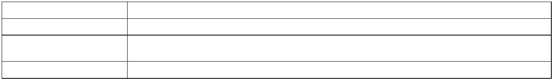

Date 29 October 2022

Team ID PNT2022TMID54187

Project Name Fertilizers Recommendation System For Disease Prediction

Maximum Marks 4 Marks

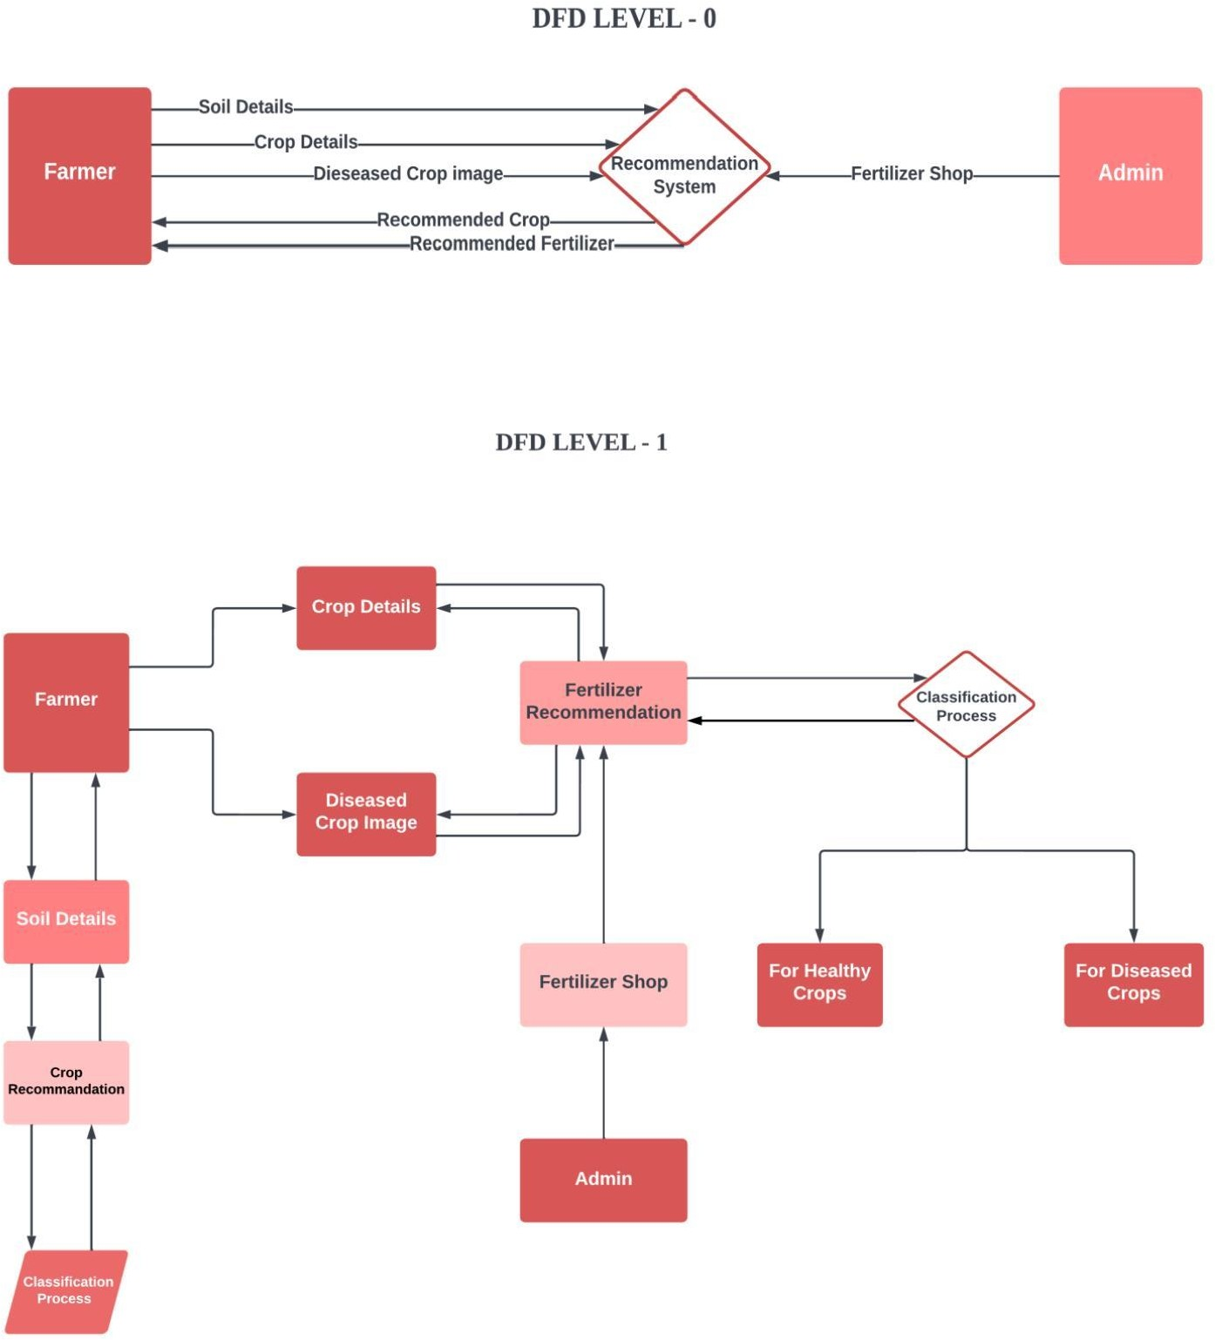

**User Stories**



dashboard

Use the below template to list all the user stories for the product.

|  |  |  |  |  |  |
| --- | --- | --- | --- | --- | --- |
| **User Type Functional Requirement**  **(Epic)** | | **User Story Number** | **User Story / Task Acceptance criteria Priority Release** | | |
| Customer (Mobile  user) | Registration USN-1 As a user, I can register for the application by  entering my email, password, and confirming my password. | | | I can access my account / dashboard | High Sprint-1 |
|  | Login USN-2 As a user, I can log into the application by entering  email & password | | | I can login using my E-mail ID accounts or user  credentials | High Sprint-1 |
|  | Dashboard USN-3 As a user, I can view the page of the  application where i can upload my images and the fertilizer should be  recommended | | | I can access my account/ dashboard | High Sprint-2 |
| Customer (Web user) | Registration USN-4 As a user, I can login to web dashboard just  Like website dashboard  Login USN-5 As a user, I can login to my web dashboard  with the login credentials  Dashboard USN-6 As a user, I can view the web application  where i can upload my images and thefertilizer should be recommended | | | I can register using my username and  password  I can login using my User  credentials  I can access my account/  dashboard | High Sprint-3  High Sprint-3  High Sprint-4 |
|  |  | USN-7 As a user, the fertilizer recommended to me  should be of higher accuracy | | I can access my account/ dashboard | High Sprint-4 |
| **User Type Functional Requirement**  **(Epic)** | | **User Story Number** | **User Story / Task Acceptance criteria Priority Release** | | |
| Administrator Login USN-8 As a admin, I can login to the website using  my login credentials | | | | I can login to the website using my login credentials | High Sprint-5 |
|  | Dashboard USN-9 As a admin, I can view the dashboard of the  application | | | I can access my | High Sprint-5 |